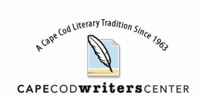

CCWC Writers Group Applicant Questionnaire

Name: _____________________________________ Town where you live: _____________________

Are you a current CCWC Member? (circle one) Yes/ No

In what genre(s) do you write?

Describe your current writing level: Beginner, Intermediate, Polished, Advanced, Published?

Have you studied writing? (If so, where and when?)

Have you won any contests or awards? (If yes, please describe.)

If published, please give title(s) and publisher(s)

Are you willing to travel to a nearby town to join one of our groups? Approximately how far?

Please briefly describe your current project:

The stage in your writing process:

Your goals for the project:

What are your expectations for participation in a CCWC critique group?

